**GUI Parking Spot System – GUI Components**

**Sang Vo - 104020390**

**Design Diagram**

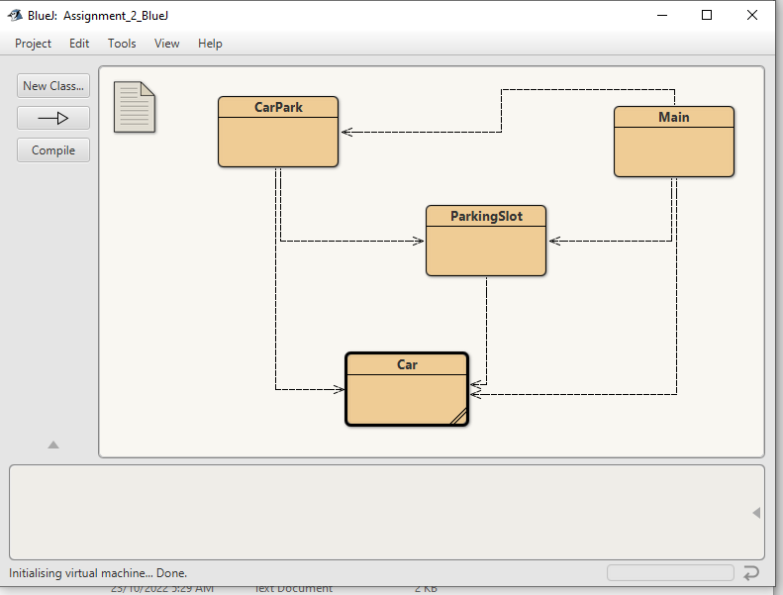

**GUI (Graphical User Interface)**

The page (frame) consists of various panels and layouts used which are referenced below:

* Main frame using a **boarder layout**
  + Panel 1 (NORTH) – contains title of the project
  + Panel 2 (WEST)
  + Panel 3 (EAST)
  + Panel 4 (SOUTH) – contains copyright symbol & name
  + Panel 5 (CENTER) – contains the 7 buttons which is evoked by their respective event handling functions and is further divided into subsequent panels to make the design more usable
    - Panel 5a utilizes a **grid layout** with two columns – this is where the primary buttons are contained
    - Panel 5b utilizes a **box layout on the x-axis** – contains the parking slots and car details, this is further divided into staff and visitor panels
      * Panel 5b1 utilizes **grid layout** with one column – contains staff data
      * Panel 5b2 utilizes **grid layout** with one column – contains visitor data

**Event Handling Functions**

1. addSlot – Add a parking slot provided a non-existing slot ID within the correct form, regex [A-Z][0-9]{2}. Additionally slots will have a type of either “Staff” or “Visitor”.
2. deleteSlot – Delete slot provided an existing slot ID number by the user. Another event handling function also exist when user clicks on an unoccupied slot in the GUI.
3. listSlot – Iterates through CarPark Array to showcase all parking slot data (additionally, car details if it is occupied). Parked time, elapsed time, and slot occupancy (via change to purple text) is also included as well as coloured background to indicate slot type (“Staff” or “Visitor).
4. parkCar – Parks car given existing slot ID and non-existing car registration number in the regex [A-Z][0-9]{4}. Additionally car type must match slot type, owner name and parked time is also included. Another event handling function also exist when user clicks on a pre-existing slot in the GUI where they can add a car to an unoccupied slot.
5. findCar – Find car based on an existing car registration number and return details including parked and elapse time.
6. removeCar – Removes car based on user providing an existing car registration number. Another event handling function also exist when user clicks on an occupied slot in the GUI where they can remove the current parked car.
7. exitButton – Once clicked the application will close.